Results

## Figure 1

Relationship of bias factor $K=R^{*}/R$, linkage probability $P_{L}$, and vaccination reporting probability, given $P\left(V^{*}\right)=0.5$ and $R=0.25$.

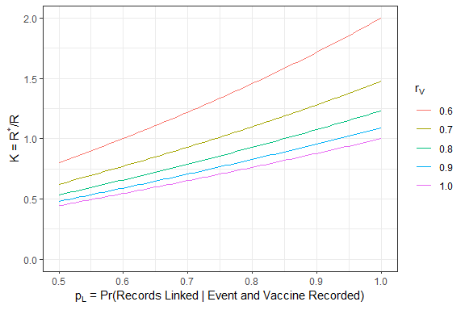

## Table 1

Simulation results with $P\left(V\right)=0.75$, $r_{D}=0.9$, $r_{V}=0.9$, and :

|  |  |  |  |  |  |  |
| --- | --- | --- | --- | --- | --- | --- |
| 1.00 | 0.95 | 0.861 | 0.861 | 0.015 | 100.0 | 100 |
| 1.00 | 0.90 | 0.745 | 0.745 | 0.013 | 100.0 | 100 |
| 1.00 | 0.70 | 0.431 | 0.431 | 0.007 | 100.0 | 100 |
| 0.25 | 0.95 | 1.114 | 1.114 | 0.029 | 0.0 | 0 |
| 0.25 | 0.90 | 1.024 | 1.024 | 0.028 | 18.1 | 8 |
| 0.25 | 0.70 | 0.712 | 0.712 | 0.020 | 100.0 | 100 |

## Table 2

Simulation results with $P\left(V\right)=0.75$, $r_{D}=0.7$, $r_{V}=0.9$, and :

|  |  |  |  |  |  |  |
| --- | --- | --- | --- | --- | --- | --- |
| 1.00 | 0.95 | 0.861 | 0.861 | 0.018 | 100.0 | 100.0 |
| 1.00 | 0.90 | 0.745 | 0.746 | 0.015 | 100.0 | 100.0 |
| 1.00 | 0.70 | 0.431 | 0.431 | 0.008 | 100.0 | 100.0 |
| 0.25 | 0.95 | 1.114 | 1.114 | 0.034 | 0.0 | 0.0 |
| 0.25 | 0.90 | 1.024 | 1.024 | 0.032 | 22.3 | 13.1 |
| 0.25 | 0.70 | 0.712 | 0.712 | 0.023 | 100.0 | 100.0 |

## Table 3

Simulation results for varying $N^{*}$ (with $P\left(V\right)=0.75$, $r_{D}=0.9$, $r_{V}=0.9$, $p_{L}=0.9$, and ):

|  |  |  |  |  |  |
| --- | --- | --- | --- | --- | --- |
| 1.20 | 13,200,000 | 1.656 | 0.045 | 0.0 | 0.0 |
| 1.10 | 12,100,000 | 1.341 | 0.034 | 0.0 | 0.0 |
| 1.05 | 11,550,000 | 1.180 | 0.033 | 0.0 | 0.0 |
| 1.00 | 11,000,000 | 1.024 | 0.027 | 18.8 | 9.5 |
| 0.95 | 10,450,000 | 0.868 | 0.023 | 100.0 | 100.0 |
| 0.90 | 9,900,000 | 0.708 | 0.019 | 100.0 | 100.0 |
| 0.80 | 8,800,000 | 0.394 | 0.011 | 100.0 | 100.0 |

Note: we haven’t worked out yet how $N^{*}≠N$ affects $K$.